Using TELL1 to MIP test sensors

Introduction

The MIP test system in the lab is designed to test the ability of a strip detector to detect beta particles. The charge generated in a silicon sensor by a singly-charged particle at very high energy isn’t very strongly affected by the particle’s specific type and energy; the particle passes through the silicon at relativistic speed, losing an extremely small proportion of its energy, generating about 80 electron-hole pairs per micron. Betas above about 1MeV have sufficiently high energy to behave in this way, so they generate a known amount of charge in a sensor (important for understanding their response), and they give a good idea of how well the detector will work in a real high-energy physics experiment. Betas at this energy are referred to as “minimum ionising particles” (MIPs) because the energy they deposit per unit distance is minimised. See, for example, [1] for a discussion of this.

The basic setup for any MIP test uses a source of betas, a detector under test, and a trigger consisting of a scintillator and a photomultiplier tube (PMT). See the picture below. A beta particle emitted by the source passes through the detector, producing a signal, and then hits the scintillator. The scintillator absorbs the beta and produces a flash of light, which is picked up by the PMT, giving a large, very fast signal. When we see this trigger signal on the PMT, we read out from the sensor being tested. This helps us to distinguish genuine MIP hits on the sensor from noise, etc. Also, applying a threshold to the size of the scintillator signal also allows us to ensure we’re only reading out from the sensor when the beta particle is high enough in energy to be a genuine MIP. (To reach the scintillator, a beta must be high enough energy to pass through the sensor and the module, so this in itself gives some energy discrimination.) In the setup in the lab, the beta source has a collimator, allowing us to produce a narrower beam of betas.

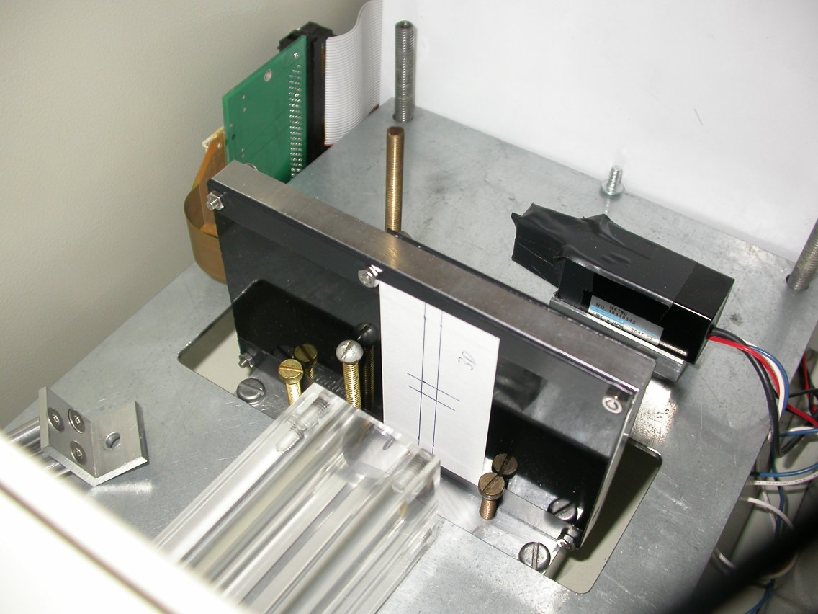
Detector box
Source holder
Detector module
Photomultiplier tube
PMT power and output connections
Ribbon cable to repeater board

With a simple pad detector, we only have one detector channel to bias and read out, so this can be done with a single voltage source and a couple of amplifiers. To read out a full strip detector, we need more specialised readout electronics. In the setup in the lab, we use electronics designed for use with the Velo at the LHCb experiment [2].

In our lab setup, each strip detector is connected to a Beetle readout chip [3] mounted on a module. Each strip is connected to a channel on the Beetle, which is responsible for amplifying the strip signal, sampling it, and storing the result temporarily in a pipeline, once every 25ns clock cycle. When the Beetle receives a trigger signal from the readout board, all the strip signals taken at the appropriate sample time can be read out serially.

The TELL1 is a readout board for the LHCb experiment at CERN. A single TELL1 is able to read out data from 16 Beetle strip detector chips simultaneously, each of which has 128 channels, giving a total of 2048. In the lab, the TELL1 may be connected to up to 4 of our Beetle modules, each of which can carry 3 Beetle chips and strip detectors.

The TELL1 is described in [4]. A fuller description can also be found in [5]. (Both these publications can be found on the official TELL1 homepage: http://lphe.epfl.ch/~ghaefeli/index.htm.) The main functions of the TELL1 in the lab setup are:
- The TELL1 contains a credit-card-sized PC (CCPC). This can be controlled remotely by a desktop PC, using an ethernet connection. This allows us to configure the TELL1, and also send artificial trigger signals, test pulses etc.
- The TELL1 sends signals to the Beetle modules, using an I²C connection, allowing us to configure the Beetle chips themselves. Once again, this is controlled by the CCPC
- The TELL1 takes external clock and trigger signals, and passes these on to the Beetle module.
- After a trigger signal, the TELL1 receives the appropriate strip signals from the Beetle, performs analog-to-digital-conversion, and then sends this data back to the control PC using a Gigabit Ethernet connection.

Using the output signal from the photomultiplier tube as a starting point, a set of NIM modules produce an appropriate trigger signal for the TELL1. This allows us to choose what signal amplitude we require on the PMT to qualify as a hit, and also gives us some control over timing issues that will be discussed later.

Ultimately, the data collected during the MIP tests is sent back to the control PC over a Gigabit Ethernet connection. A piece of LHCb software running on the PC, the Event Builder, receives these packets of data and assembles them into a single data file. In the LHCb experiment, this event builder would be responsible for assembling the data from all the different detector subsystems.

This data file consists of all the raw ADC values on each strip read out by the TELL1. To get useful information we need to process the data to remove pedestals, common-mode noise and other problems, and then we need to pick out the clusters of strip signals corresponding to genuine hits on the detector. In LHCb, this would all be done on board the TELL1 itself. In the lab, we instead use a piece of LHCb software called Vetra. Vetra will then output the hit data into ROOT files. ROOT is a data analysis system created by CERN, based on C++, which has many built-in functions for dealing with particle physics data. Using ROOT, we can work with the hit data file to produce, for example, the signal spectrum seen in the detector or the distribution of hits in the sensor. So, we can test the sensors for charge collection efficiency, charge sharing, reliability and so on.

The Beetle Readout Chip

The Beetle readout chip is described in detail in its manual [3]. Other papers on the chip can also be found from the CERN document server.

The block diagram of the Beetle, copied from the manual, is shown below.

Beetle sampling, timing, and triggering

A major feature of the chip is that it makes analogue measurements of strip signals, rather than simply detecting whether the signal exceeds a threshold. This gives us better information about the signal received from the sensor. The input pulse passes through a preamplifier and a shaper, and the output of the shaper is sampled on the clock edge of the Beetle, every 25ns. These samples are temporarily stored in a pipeline, so that they can be read out if a trigger signal is received.

The pulse output from the shaper when a hit occurs is shown below. The peaking time is of order 20ns, depending on the particular settings of the Beetle chip. In order to reliably measure the strip signals, we need to find the signal at the peak of this shaper pulse. In the LHCb experiment, the collisions between proton bunches occur every 25ns, with precise timing. This means that, if we properly synchronise the 25ns clock on the Beetle chip with the LHCb bunch crossings, we can always be certain that we’ll sample the shaper pulse at its peak, without any need for any peak-finding electronics on the chip.

However, when we move into the lab, the beta particles hitting the detector will be completely random with respect to the Beetle’s clock. So, rather than reliably sampling the peak of the pulse, we might be sampling anywhere within a 25ns range around the peak! The solution to this problem is to measure the time of the hit signal on the photomultiplier, relative to the clock. Then, we accept only those hits that occur at the particular time we want. In most cases this will be the peak of the pulse, but it’s also possible to vary the timing we use in order to study the shape of the pulse from the shaper.

In our trigger system, we pass the photomultiplier signal through a discriminator, to select the beta hits with more than a certain energy. Using the same pattern generator that generates our 25ns clock signal, we also produce an “acceptance window” 5ns wide, with a fixed phase relative to the clock. We will only accept the discriminated trigger signal if its timing coincides with this acceptance window. This means we can select only the hits that occur at the required time relative to the clock, within a range of 5ns (which is acceptable, given the breadth of the peak). An example of this logic is shown below. We then have to do further processing, to get a trigger signal that the TELL1 can accept. The full trigger logic is described later.

25ns clock
Acceptance window – 5ns wide, 25ns period
Discriminated photomultiplier signal – pulses of a few ns
Output of acceptance window AND PMT
Fixed phase relative to clock edge
Hit not accepted
Hit accepted
Beetle configuration

The Beetle chip has 20 registers to control its behaviour. The section on configuring the Beetle chips and the TELL1 explains how to alter the configuration files to change these registers. Details of the registers are described in the Beetle Reference Manual. Here, I’ll just describe the most important registers. Below are a list of the registers, and the Beetle’s schematic.

Register 0 controls the amplitude of the test pulses, with the pulse height typically being 1025e- multiplied by the value in this register.

Registers 1-5 control various settings of the front end (preamplifier, shaper, buffer). These can change the response of the front end (gain, timing) so they should be kept constant during an experiment. In my tests of the system, the only issue I’ve had is with Vfp and Vfs. In both the preamp and shaper, integration of a current signal is done by charging up a capacitor with the current. Then, feedback transistors allow the capacitor to discharge. Vfp and Vfs control the effective resistance of the transistors. If Vfp is set too high, then the preamplifier cannot operate with DC coupled detectors. Reasonable settings are Vfp=00 and Vfs=47. Note that these are hex values.

Register 16 controls the latency, i.e. the length of the readout pipeline. This should be set so that the time to pass through the pipeline (25ns * pipeline length) matches the time delay between the hit occurring on the Beetle and the trigger arriving. In the lab setup, this is 13hex (19 decimal) if we want to take 5 samples, starting just before the hit occurs, and less (typically 11hex) if we want to just take one sample at the peak.

Physical setup of system

See the appendix for a series of photos of the system, with parts labelled.

Aside from the parts listed here, the detector module sits inside a box while it is tested with a Sr-90 source. It is also possible to put the entire detector box inside a cooled environment chamber during running. This is important for reducing leakage current in radiation-damaged sensors.

Trigger logic

There are 2 functions to the trigger logic.

Firstly, we must take the hit signal on the scintillator and PMT, and accept it only if it arrives at a specific time relative to the system clock. As described in the section on the Beetle chip and its timing, we need to do this so that we know exactly when the pulse from the Beetle’s front end has been sampled. The time relative to the clock can be scanned to see the shape of the pulse, and then set to the appropriate value to catch the front-end peak every time. This part of the logic is done by generating a narrow “acceptance window” on the same pattern generator that produces the clock, and then AND-ing this with the photomultiplier signal, after we’ve run it through a discriminator.

Secondly, once we’ve made the decision to trigger, we need to produce a suitable trigger signal for the TELL1. Firstly, the dual timer sets the appropriate length – for N readout samples, we set it to n*25ns. Then, we need to adjust its timing. As shown in the diagram at the bottom, the TELL1 looks at the trigger signal every falling edge of the clock when deciding if to trigger. The delay allows us to fine-tune the arrival time of the trigger, to make sure the trigger signal doesn’t change near to the clock edge, which would cause unpredictable results. This delay should be adjusted to compensate for changes in the acceptance window timing. Finally, there is a level shifter to give the correct logic level.

A photo of the modules used for this trigger logic appears in the appendix.

CABLE LENGTHS AND THE USER GUIDE

Note that if the lengths of any of the cables prior to the 4-fold logic unit are changed, then this could alter the relative timing of the PMT signal and the trigger acceptance window. For example, if the trigger acceptance window is delayed an extra 5ns due to a longer cable, then we will end up accepting triggers that are 5ns later relative to the clock. If cables need to be changed, you should either change both signal paths equally, or at least remember the change in timing when working with the trigger accept window. Likewise, the length of the clock cable to the TELL1 is important, since it will affect the relative phase of the acceptance window and the sampling time.

The timing settings described in the step-by-step guide assume that the cable lengths are:
Acceptance window signal from pattern generator to logic unit – 13ns (8+5)
PMT to discriminator – cable from PMT + 150cm
Discriminator to logic unit – 10ns.

It’s not vital that you use these specific settings, just that the cable lengths are kept consistent during an experiment.

APPENDIX – PICTURES OF SYSTEM

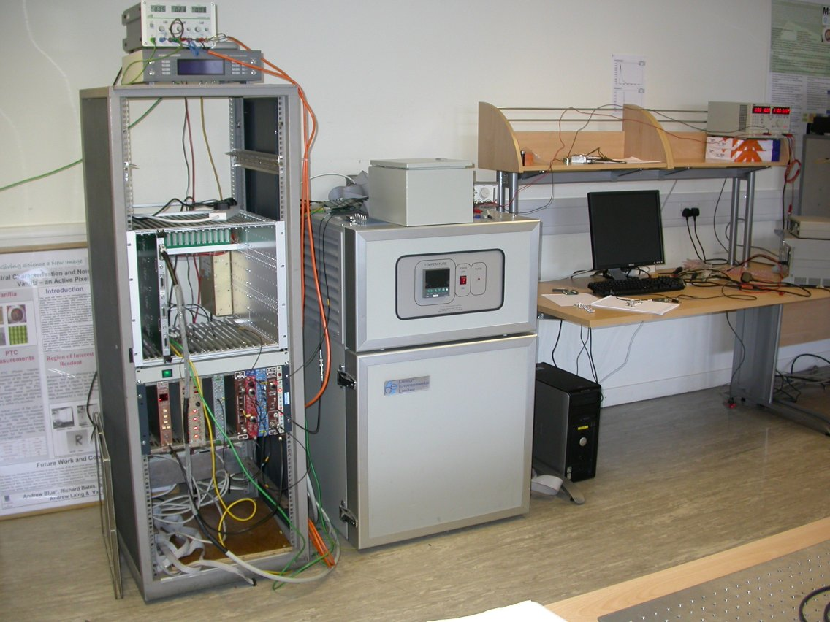
TELL1
Environment chamber
Control PC
MIP test setup
Test box

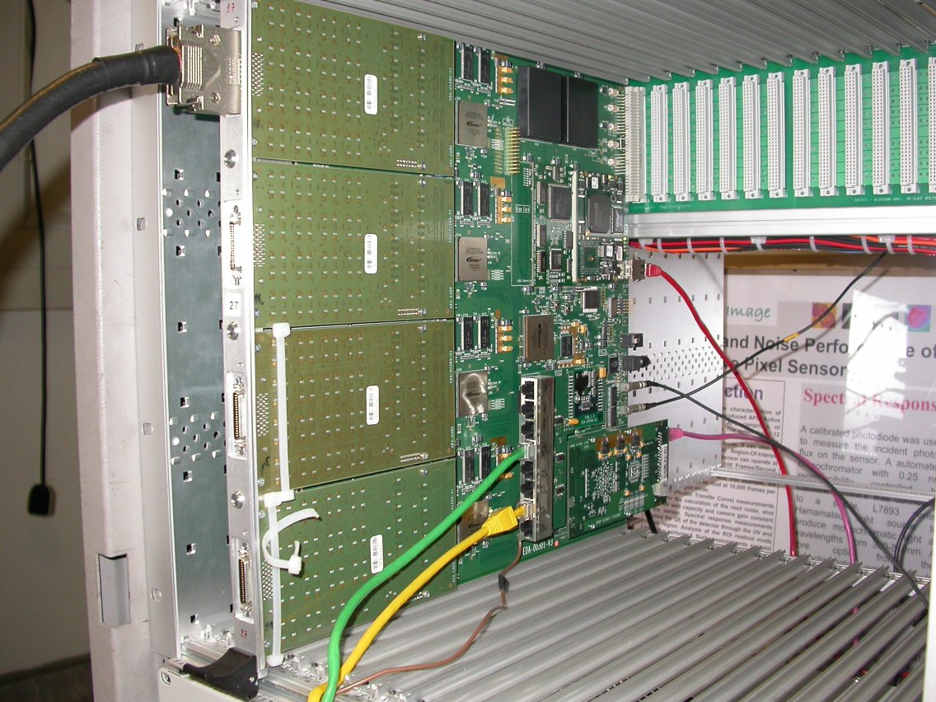
ADC cards
Data cable from repeater board
TELL1
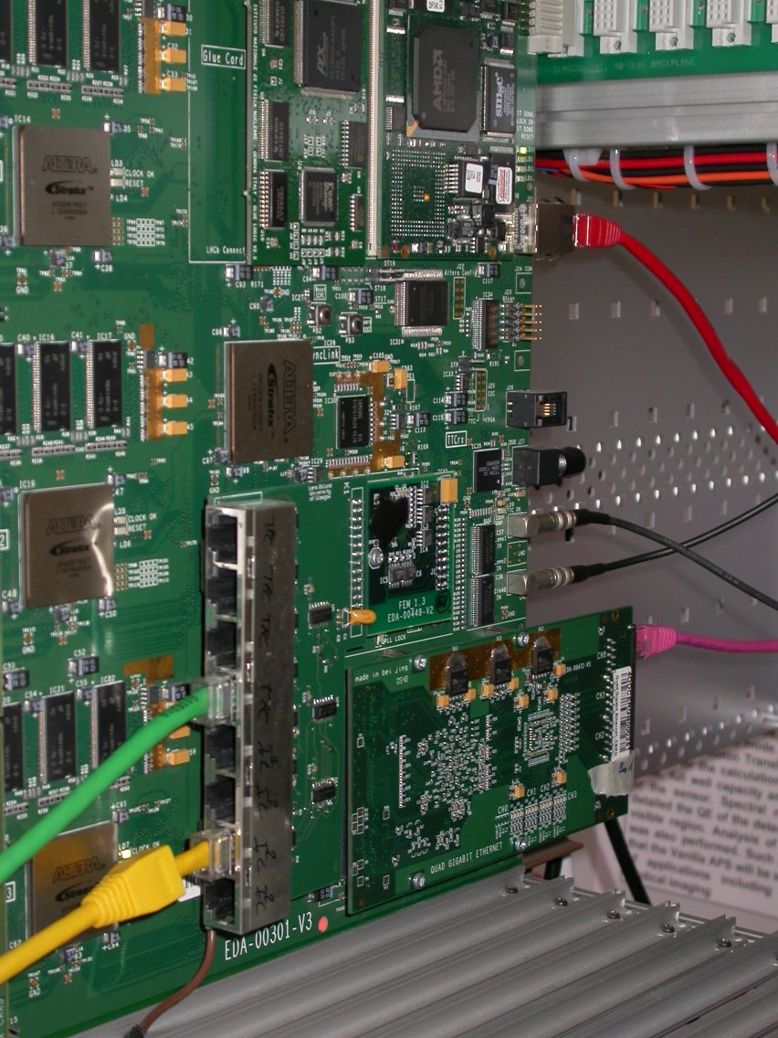
TELL1 - Detail
Trigger adaptor - TFC
Trigger adaptor – I²C
To repeater board
Trigger (top) & clock (bottom) LEMO inputs
CCPC
To router
Gigabit Ethernet card
To PC
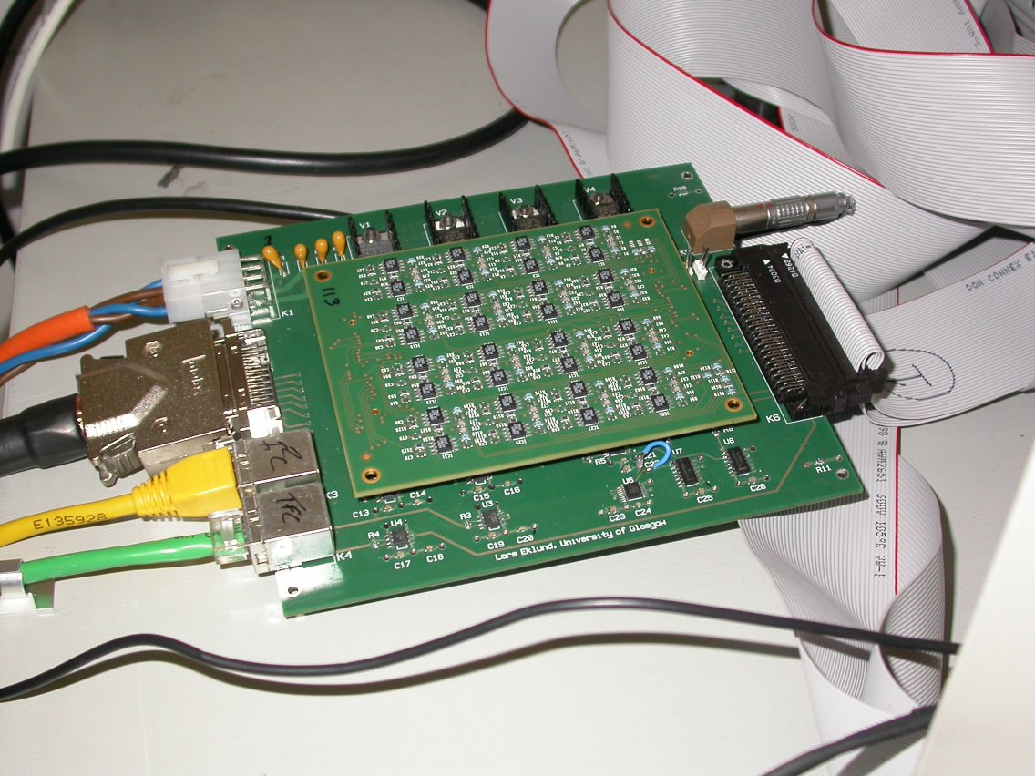
Data cable to TELL1
TFC and I²C from TELL1
Power from supply
Bias voltage from HV supply
Ribbon cable to module
Repeater board

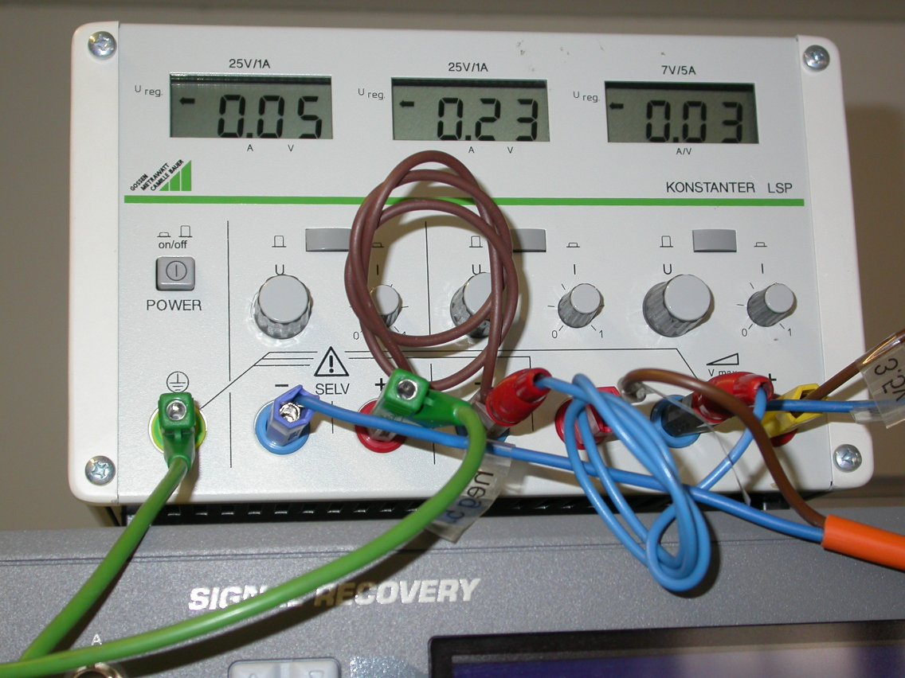
Power for repeater board
-5.5V
+5.5V
0V, +3.5V
Cable to repeater board

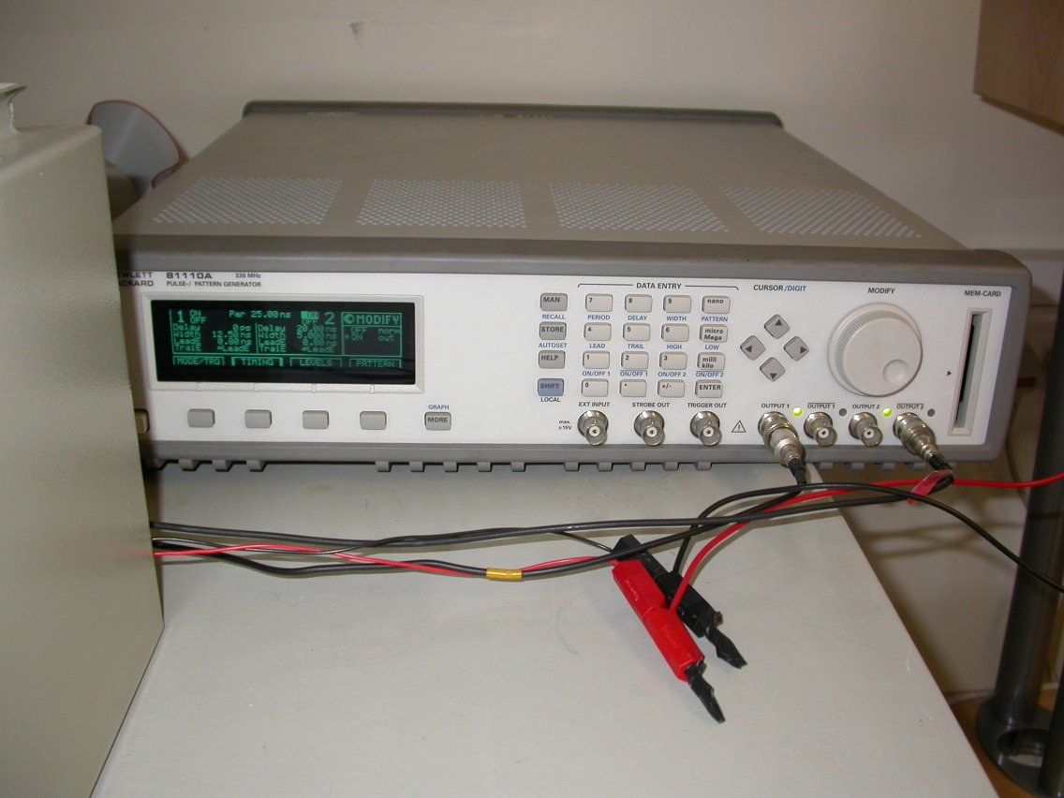
Pattern generator
Output 1 – clock to TELL1
Output inv 2 – trigger accept window to 4-fold logic unit

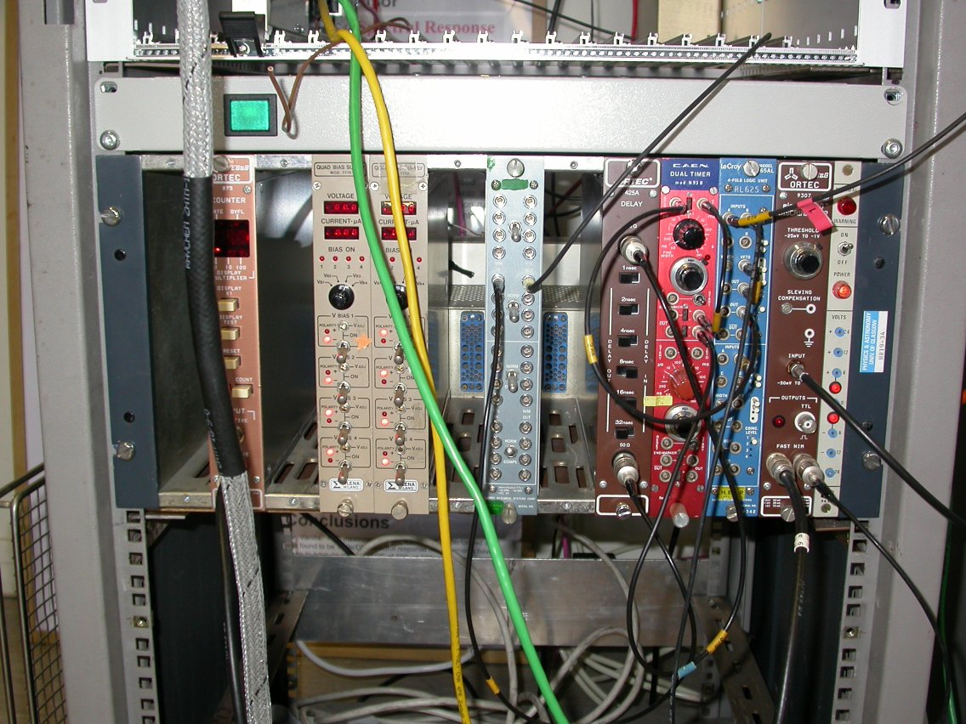
NIM crate
Bias supply – output HV cable on back to repeater
Discriminator – input from PMT in test box
4-fold logic unit Trigger accept from pattern generator AND discriminator
Dual timer – generates trigger signal
Delay unit – adjust timing
Level shifter
Trigger signal to TELL1

Detector box
Source holder
Detector module
Photomultiplier tube
PMT power and output connections
Ribbon cable to repeater board

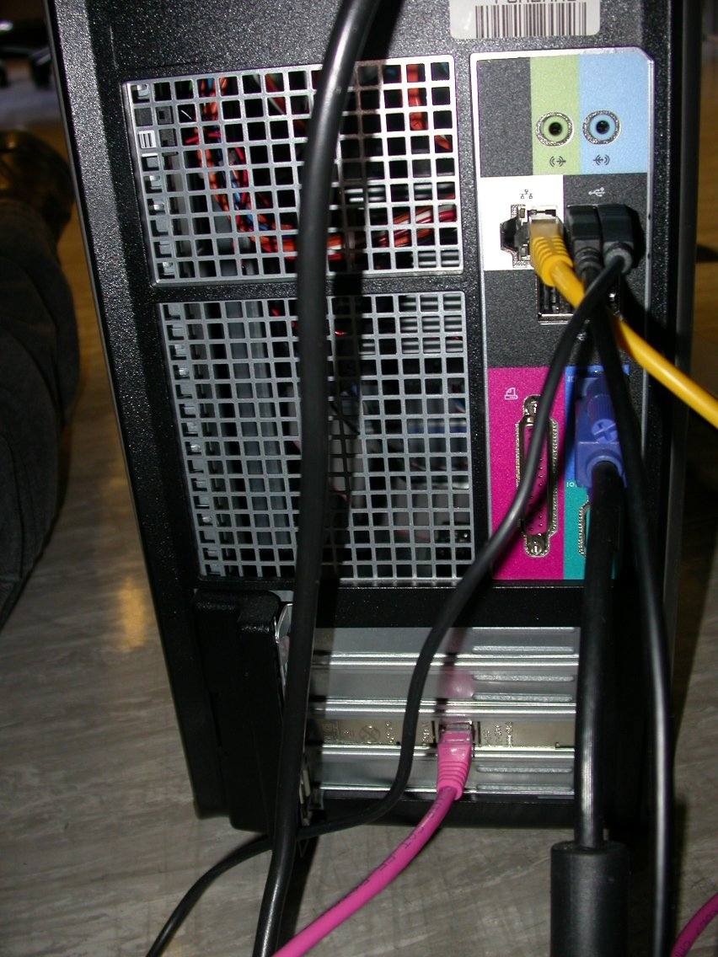
Back of PC
Ethernet cable to router
Gigabit Ethernet cable to GBE card on TELL1

Reference List

1. W. R. Leo, in Techniques for Nuclear and Particle Physics Experiments: a how-to approach, 2nd revised ed., (Springer-Verlag, Berlin Heidelberg New York, 1994).
2. A. Gouldwell-Bates, Developments in Silicon Detectors and their impact on LHCb Physics Measurements, Thesis, Glasgow Univ, 2005. Preprint / cern / thesis-2006-003, available from CERN doc. server at http://doc.cern.ch/archive/electronic/cern/preprints/thesis/thesis-2006-003.pdf
3. S. Löchner and M. Schmelling, LHCb-2002-055; CERN-LHCb-2002-055, The Beetle Reference Manual - chip version 1.3, 1.4 and 1.5, 2008.
4. G. Haefeli et al., Nuclear Instruments & Methods in Physics Research Section A-Accelerators Spectrometers Detectors and Associated Equipment 560, 494 (2006).
5. G. Haefeli, Contribution to the development of the acquisition electronics for the LHCb experiment , Thesis, EPFL Lausanne, 2004. Preprint / cern / thesis-2004-036, available from CDS at http://documents.cern.ch/cgi-bin/setlink?base=preprint&categ=cern&id=cern-thesis-2004-036

