|  |
| --- |
| Flex Thermal |
| Altium Project for implementing a flex thermal board |
|  |
| This Project aims at developing a Flex PCB to measure the thermal heating of the Sensor Module. It also involves developing a test pcb to test the flex thermal. |
|  |

Flex Thermal

Altium Project for implementing a flex thermal board

# The Design

The design has resistance through trace between voltage in and voltage out.

In addition we have used the three differential data pairs and one NTC pair to mount 5 NTC’s on the PCB; four in the four corners of the board and one at the center for temperature monitoring.

From the simulations of the Quad module it appears that we can cool 16W in the quad before the sensor runs away.

So we have to try to set the resistance to be such that we have a power of 16W for 2.2V, close to the nominal voltage for the ROIC supply.

We need to create a resistance using PCB trace that gives 16 W power dissipation for 2.2 V.

Calculated value of resistance is 0.302 Ohms.

Using trace width calculator we get the following output.

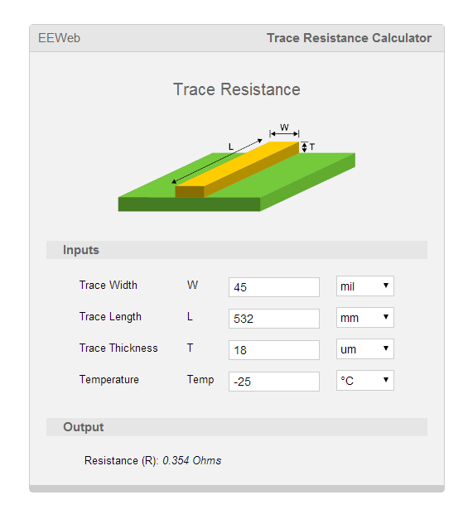 

Trace width of 532 mm at 45mm trace width is achieved in the critical section (The section that would overlap on the sensor) of the layout.

Schematic Layout



Reference Schematic

This is the pin outs on the connector AXT640124 on the Electrical Board (Ilya’s Design Schematic)



PCB Specifications of the Flex Thermal

* The PCB is a two layer Flex Board with Kapton layers 25 um thickness and Cu layers of 18 um.
* We have 2 options for Flex Stackup as mentioned below.

PCB Layer Stack

* Stackup without Adhesive

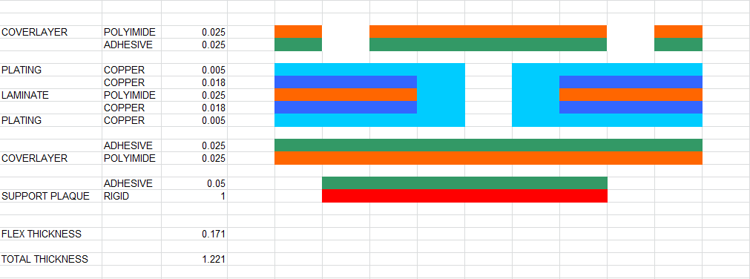

* Stackup with Adhesive

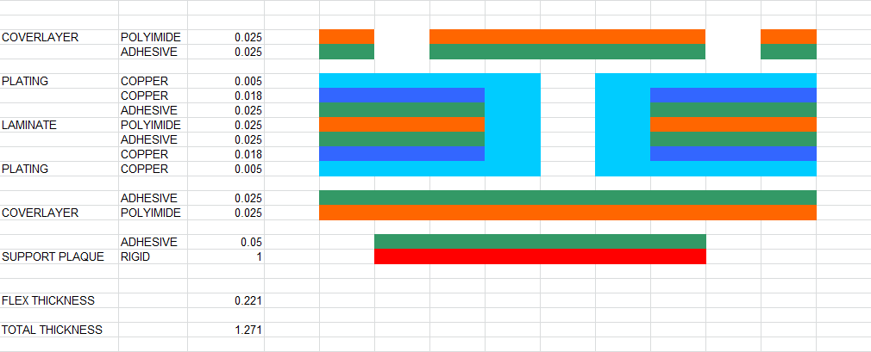

* The size of the flex matches that of the electrical flex designed by Ilya.
* Trace width/trace spacing 0.15mm/0.127mm
* Min Hole size 0.381 mm
* Cu Finish: ENIG
* The connector we are using on the flex is the 40 pin Header AXT640124.

The NTC is a 10K, 1% Tol –Panasonic ERTJ1VG103FA

* There are alignment marks in four corners of the flex as shown below

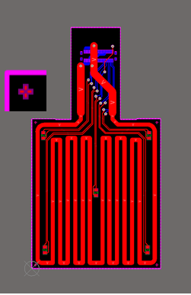

**Red –Top Layer , Blue-Bottom Layer**

Panel for Flex Design (To Align with the Jig)



We would be adding all the mounting holes (all holes would be M5) on the panel but we would mainly use the ones marked in yellow for aligning with the existing Jig.

An additional mounting hole would be added (in pink) for future use.

Our Rigid Panel would be a PCB Frame with a routing slot and Flex breakaway tabs at the showed locations in the drawing below.



Routing Slot Calculations



Horizontal Cross Section of the Thermal Flex Assembly

Calculation of the Routing Slot width

38.2 mm – 34.6 mm = 3.6 mm

3.6 mm/2 = 1.8 mm +2 mm clearance = 3.8mm on either sides vertically.



Vertical Cross Section of the Thermal Flex Assembly

Calculation of the Routing Slot width

41.3 mm – 40.2 mm = 1.1mm

1.1 mm/2 = 0.55 mm +2 mm clearance = 2.6 mm on either sides horizontally.

Test PCB for the Thermal Flex

The test PCB is designed to connect to the Thermal Flex with the connector AXT540124. It has two Molex headers for testing purpose.

Schematic Layout



PCB Layout

* Double layer rigid 1.6mm FR4.

* Trace width/trace spacing 0.15mm/0.127mm
* Min Hole size 0.381 mm
* Cu Finish: ENIG
* The connector we are using on the flex is the 40 pin Socket AXT540124 and

Molex 8 Pos Header - 0039300080

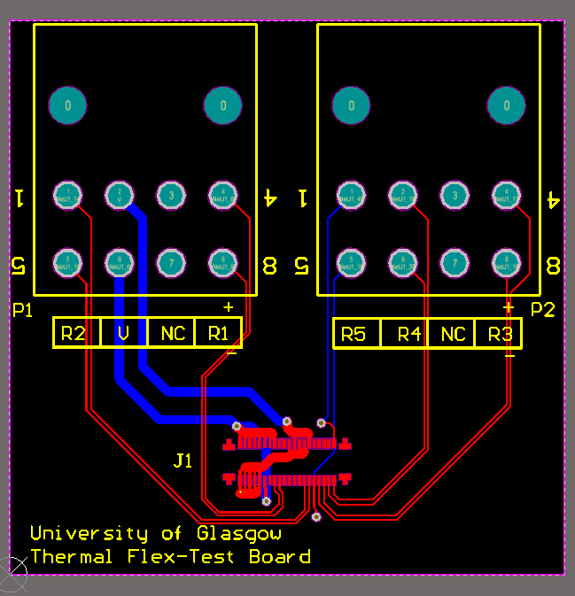

**Red –Top Layer, Blue-Bottom Layer**